
STUDY HANDOUT | AI & ML PLAYGROUND
BAYES'
THEOREM
Updating Beliefs with New Evidence

What Is Bayes' Theorem?
Bayes' Theorem provides a rigorous mathematical foundation for updating our beliefs or probabilities when we receive new evidence.
The spam email intuition: Before opening an incoming email, you have an initial belief about whether it is spam (for example, based on overall inbox averages). But as soon as you open it and discover suspicious phrases like "Act Now! Free Cash Wire Transfer", you immediately update that belief. Because spam emails contain suspicious buzzwords much more frequently than regular emails, your confidence that this message is spam jumps dramatically.
In the real world, this updating mechanism is central to spam filters (Naive Bayes), clinical medical diagnosis, self-driving perception systems, and Bayesian machine learning.
Connect It to Conditional Probability
In conditional probability, we learned that conditioning on an event zooms into a smaller world: P(A | B) = P(A ∩ B) / P(B) where P(B) > 0. However, students frequently confuse the direction of the condition:
P(POSITIVE | DISEASE)  If a person actually has the disease, what is the probability that the test is positive?  This measures Test Sensitivity (lab accuracy). |  | P(DISEASE | POSITIVE)  If a person tests positive, what is the probability that they actually have the disease?  This measures Clinical Reality (patient certainty).

The fundamental lesson: These are completely different questions. Doctors and patients want to know P(Disease | Positive), but medical trials only evaluate the equipment to measure P(Positive | Disease). Bayes' Theorem is the mathematical bridge that calculates the second from the first.
The Bayes' Theorem Formula
THE FORMULA
P(A | B) = [ P(B | A) × P(A) ] / P(B)
where P(B) > 0

Prior — P(A) | What we believed before seeing the new evidence (base rate of event A).
Likelihood — P(B | A) | How likely the evidence B is to occur if event A is indeed true.
Evidence — P(B) | The overall probability of observing the evidence under all possible conditions (must be > 0).
Posterior — P(A | B) | Our updated probability of event A after incorporating the new evidence B.

MEMORY AID
Posterior = Likelihood × Prior ÷ Evidence
Where Does Bayes' Theorem Come From?
Bayes' Theorem is not a magic axiom; it comes directly from the multiplication rule and the definition of conditional probability in four simple algebraic steps:
1. Express joint probability P(A ∩ B) using conditional probability: P(A ∩ B) = P(A | B) × P(B)
2. By symmetry of intersections, reverse the events: P(A ∩ B) = P(B | A) × P(A)
3. Since both expressions equal P(A ∩ B), set them equal: P(A | B) × P(B) = P(B | A) × P(A)
4. Divide both sides by P(B) (where P(B) > 0): P(A | B) = [ P(B | A) × P(A) ] / P(B)
Three Key Words in Plain English
Every medical-test problem uses the same three numbers. Here is each one in everyday language, using one picture: the test is a smoke alarm and the population is a town full of houses.
WORD 1  Prevalence  How common is it? | IN PLAIN WORDS Before we test anyone, how common is the disease? Out of everybody, what share is actually sick?  PICTURE IT A town with 100 houses where 1 house is on fire right now. The fire rate in the town is 1 in 100, so prevalence = 1%. Nobody has pulled out a smoke alarm yet. This is only about the town, not about the alarm.  IN OUR EXAMPLE 1% prevalence, so in 10,000 people, 100 are sick and 9,900 are healthy.  P(D) = 0.01 (this is the Prior from Bayes’ Theorem)
WORD 2  Sensitivity  Does the test catch the sick? | IN PLAIN WORDS If someone really is sick, how often does the test catch it? Sensitivity only looks at the sick people.  PICTURE IT A smoke alarm in a house that is truly on fire. A sensitive alarm almost always rings. A weak one sometimes stays silent while the house burns. That silent miss is a false negative.  IN OUR EXAMPLE Of the 100 sick people, the test flags 95 (true positives) and misses 5 (false negatives).  P(+ | D) = 0.95 (this is the Likelihood)
WORD 3  Specificity  Does the test leave the healthy alone? | IN PLAIN WORDS If someone is healthy, how often does the test correctly say “nothing wrong”? Specificity only looks at the healthy people.  PICTURE IT The same smoke alarm in a house where you just burned toast. A specific alarm stays quiet. A poor one screams anyway. That false alarm is a false positive.  IN OUR EXAMPLE Of the 9,900 healthy people, the test clears 9,405 (true negatives) and wrongly flags 495 (false positives).  P(− | Dᶜ) = 0.95 so False Positive Rate = 1 − 0.95 = 0.05

WORD | WHICH GROUP IT LOOKS AT | ONE-LINE QUESTION | OUR NUMBERS
Prevalence | Everyone (the whole population) | How many are sick? | 1% of 10,000 = 100 sick
Sensitivity | Only the sick group | How many sick get caught? | 95 of 100 caught
Specificity | Only the healthy group | How many healthy get cleared? | 9,405 of 9,900 cleared

EASY WAY TO REMEMBER
Sensitivity = sick group. Specificity = healthy group. Prevalence = how big the sick group is to begin with.
Sensitivity and specificity describe the test, so they stay the same no matter who you test. Prevalence describes the people being tested, so it changes from town to town. What a patient really wants, P(D | +), depends on all three. That is exactly why we need Bayes’ Theorem to combine them.
Main Worked Example: A Medical Test
WORKED EXAMPLE MEDICAL SCREENING
Interpreting a Rare Disease Positive Test
SCENARIO & CLINICAL DEFINITIONS
• Prevalence P(D): 1% of the population has the disease: P(D) = 0.01, so healthy P(Dᶜ) = 0.99.
• Sensitivity P(+ | D): Among people who have the disease, 95% test positive: P(+ | D) = 0.95.
• Specificity P(− | Dᶜ): Among healthy people, 95% test negative: P(− | Dᶜ) = 0.95.
• False Positive Rate P(+ | Dᶜ): 1 − Specificity = 1 − 0.95 = 5%: P(+ | Dᶜ) = 0.05.
QUESTION & TWO-STEP SOLUTION
If a person tests positive (+), what is the probability that they actually have the disease: P(D | +)?
Step 1: Calculate total probability of a positive test P(+)
P(+) = P(+ | D) × P(D) + P(+ | Dᶜ) × P(Dᶜ)
P(+) = (0.95 × 0.01) + (0.05 × 0.99) = 0.0095 + 0.0495 = 0.059 (5.9%)
Step 2: Apply Bayes' Theorem
P(D | +) = [ P(+ | D) × P(D) ] / P(+) = (0.95 × 0.01) / 0.059 ≈ 0.161 = 16.1%
ANSWER Approximately 16.1%
WHY THIS HAPPENS
Despite a 95% accurate test, a positive result gives only a 16.1% chance of disease. Because the disease is rare (1%), the sheer size of the healthy group (99%) creates far more false positive cases than the small sick group creates true positives.
Make the Calculation Visual: Out of 10,000 People
Formulas can feel abstract. Looking at actual counts across 10,000 people makes the 16.1% result immediately intuitive:
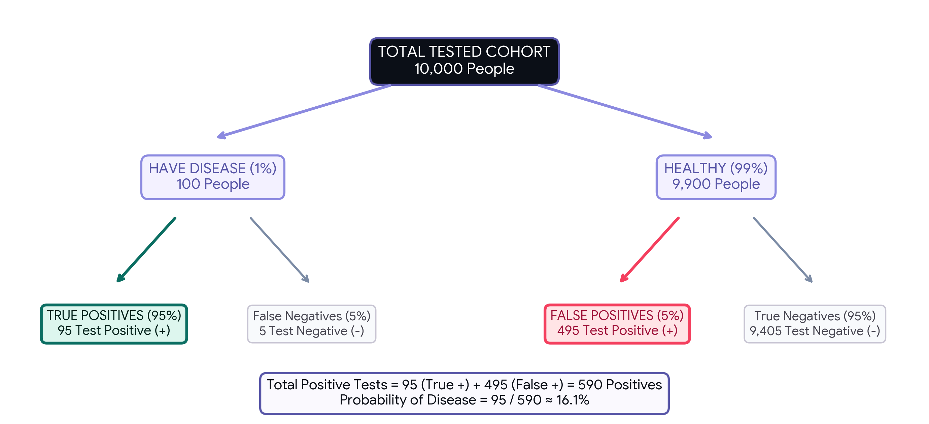
DIAGNOSTIC STATUS | TESTED POSITIVE (+) | TESTED NEGATIVE (−)
100 Sick (1%) | 95 True Positives | 5 False Negatives
9,900 Healthy (99%) | 495 False Positives | 9,405 True Negatives

The intuitive takeaway: Count the positive tests: 95 true positives + 495 false positives = 590 total positive tests. Of those 590, only 95 actually have the disease: 95 / 590 ≈ 16.1%. The mystery vanishes when you look at the raw counts!
Why Prevalence Changes Everything
Prevalence is how common a condition is in the target population. Keep sensitivity (95%) and specificity (95%) completely fixed—notice how dramatically the positive predictive value changes with base prevalence:
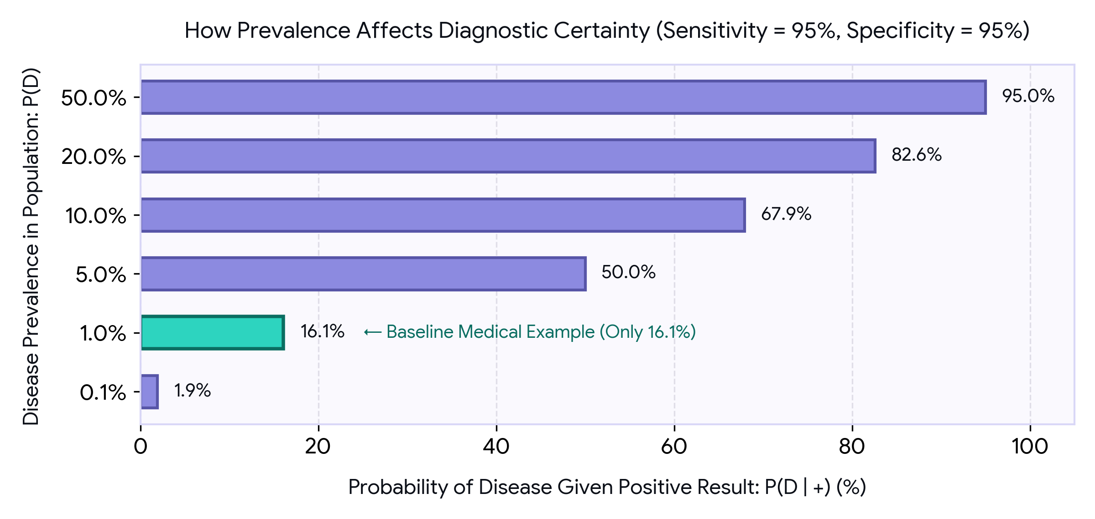
Disease Prevalence P(D) | Probability of Disease Given Positive Result P(D | +)
0.1% | 1.9%
1.0% | 16.1% (Our baseline example)
5.0% | 50.0% (Coin flip certainty)
10.0% | 67.9%
20.0% | 82.6%
50.0% | 95.0% (Equals sensitivity)

Key Takeaway: The exact same test produces vastly different positive predictive values depending solely on population prevalence. In a general screening where a disease is rare, false positives dominate. In a specialized clinic where the condition is common, a positive test is overwhelmingly conclusive.
Bayes' Theorem in Python
Here is how simple Bayes' Theorem is to express in code. This clean Python function implements the law of total probability and Bayes' rule:
● ● ● bayes.py
def bayes(prior, sens, spec):
# Probability of a positive test
p_pos = sens * prior + (1 - spec) * (1 - prior)

# Probability of disease given a positive test
return sens * prior / p_pos

# 1% prevalence, 95% sensitivity, 95% specificity
post = bayes(0.01, 0.95, 0.95)
print(round(post, 3)) # 0.161
How the code works
• Function parameters: prior represents the initial probability of disease (0.01), sens is test sensitivity (0.95), and spec is test specificity (0.95).
• Evidence calculation: p_pos calculates the total probability of testing positive across both sick and healthy individuals (0.059).
• Posterior calculation: The return statement multiplies likelihood by prior and divides by evidence, outputting 0.161 (approximately 16.1%).
What Happens After a Second Positive Test?
The iterative power of Bayes: Today's posterior becomes the next test's prior. If a patient tests positive once, we do not throw that information away. When they take a second test, our baseline belief is no longer 1%—it is 16.1%!
● ● ● second_test.py
# Posterior after the first positive test
p1 = bayes(0.01, 0.95, 0.95)

# Use the updated probability as the next prior
p2 = bayes(p1, 0.95, 0.95)

print(round(p1, 3)) # 0.161
print(round(p2, 3)) # 0.785

Probability Progression: Initial prior = 1% ⟶ After 1st positive test = 16.1% ⟶ After 2nd positive test = approximately 78.5%. The second positive test substantially boosts confidence because it adds fresh, cumulative evidence.
Important Clinical Assumption: This calculation assumes that the two test results are conditionally independent given disease status and that both tests maintain identical sensitivity and specificity. In clinical medicine, repeated testing may share common error sources, so doctors use distinct diagnostic modalities.
Practice Questions
PRACTICE QUESTIONS
Question 1: What is the core difference between test sensitivity and test specificity?
A. Sensitivity is the probability of disease; specificity is the probability of health.
B. Sensitivity is P(+ | Disease), while specificity is P(− | Healthy).
C. Sensitivity depends directly on prevalence, while specificity does not.
Question 2: In our worked example, why is the probability of disease after a positive test only 16.1% despite a 95% accurate test?
A. The test is flawed and should never be used in screening.
B. The disease is rare, so false positives from the large healthy population outnumber true positives.
C. Specificity was calculated incorrectly using subtraction.
Question 3: Why does the posterior probability from the first test become the prior for the second test?
A. Because Bayes' Theorem incorporates updated knowledge as the baseline before evaluating new evidence.
B. To mathematically guarantee that the probability reaches 100%.
C. Because sensitivity doubles during repeated testing.

Answer Key and Takeaway
ANSWER KEY & EXPLANATIONS
Question 1: B — Sensitivity is P(+ | Disease), specificity is P(− | Healthy)
Explanation: Sensitivity evaluates how well the test detects disease in sick patients, while specificity evaluates how well it confirms health in healthy individuals.
Question 2: B — False positives from the 9,900 healthy people outnumber true positives
Explanation: With a 1% base rate, 9,900 people are healthy, producing 495 false positives. Only 100 are sick, producing 95 true positives. 95 / 590 gives 16.1%.
Question 3: A — Bayes updates existing beliefs when presented with new evidence
Explanation: In sequential learning, yesterday's posterior belief naturally serves as the informed prior when evaluating today's subsequent test.

KEY TAKEAWAY
Never evaluate a diagnostic result in isolation from the prior base rate. Bayes' Theorem updates beliefs by balancing new evidence with existing reality.

